
RESEARCH METHODS FOR COMPUTIN AND TECHNOOGY (CT098-3-2)
INDIVIDUAL ASSIGNMENT
PART 1 – PROJECT PROPOSAL
Name | KAEMON NG BAO LENG
TP Number | TP082265
Lecturer Name | Dr. Hemalatha Ramalingam
Intake Code | APD2F2506CS(AI)
Date Assigned | 1 DECEMBER 2025
Submission Date | 23 JANUARY 2026

Public Transport Prediction: Enhancing Operational Efficiency by using Receptance Weighted Key Value (RWKV) based architecture
Kaemon Ng Bao Leng
tp082265@mail.apu.edu.my
Abstract – The rapid accelerations of global urbanization has significantly increase the demand for reliable and efficient public transport system. However, balancing between services quality and operational costs remain a severe challenge, due to complex and dynamic passengers’ flow data. While recent research has increasingly adopted Deep Learning, specifically Transformer-based architectures such as BERT Transformer Encoder, has improved prediction accuracy, but struggling in limitations of quadratic computational complexity (O(N2)). This high resource consumption leading them computationally difficult to utilize for real-time operational planning, especially during processing extensive historical data. To address this bottlenecks, this research propose a RWKV-based architectures which inspired by its success in Natural Language Processing. The RWKV-based architectures introduces a Linear Attention mechanism (O(N)) that combining the Transformer-base architecture’s parallel training capability with RNN’s inference capability. The research investigate the effectiveness of RWKV-based architecture in balancing between maintaining the high prediction accuracy and low resource consumption to enable more efficient operational planning for public transport companies.

Key Terms
Public transport, Demand prediction, Receptance Weighted Key Value (RWKV), Deep Learning, BERT Transformer Encoder, Quadratic computational complexity, Linear Attention mechanism

1.0 Introduction
With the changes of the time, global urbanization accelerates rapidly. The demand for reliable and efficient public transport system increase significantly, making accurate transportation planning become a crucial role of modern urban development (Nayak et al., 2022). As the backbone of the urban transit network, public bus services not only carry a huge daily passengers flow also directly related to quality of life of residents and urban economic productivity, (Siswanto et al., 2024). Furthermore, the latest research emphasize, public transport infrastructure optimization not only an operational task but a core driver for archiving the global Sustainable Urbans Development Goals (SDG11), (Almulhim et al., 2024).
Despite the importance of the public transport system, maintaining operation efficiently in complex urban environment presents significance challenges in practice. Factors including dense population and unpredictable weather condition, while the financial constraints on public transport companies also raise challenges, often make it difficult for public transport companies to balance services quality and operation costs, (Ku et al., 2025). This mismatch between supply and demand often leads to two extreme consequences, including overcrowding during peak hours and empty runs during off-peak hours lead to resources waste. Therefore, to address effectively these systematic inefficiencies, the industry urgently needs to find sustainable optimization strategies to increase services quality while addressing energy conservation and emission reduction also resource allocation, (Fatorachian & Kazemi, 2025).
To address these challenges, earlies study shift from traditional statistics model to machine learning model. For example, the researcher utilize Support Vector Regression (SVR) to predict the profitability of the bus route, aim to save the cost expense for the bus companies, (Ku et al., 2025). Expanding on this, the researcher applied a Deep Learning Long Short-Term Memory model to enhance the demand prediction accuracy, (Siswanto et al., 2024). Nevertheless, despite these methods gain success in specific tasks, their limitation still cannot be ignore. SVR as a shallow model, it difficult to capture complex and non-linear patterns, on the other hand, although LSTM is a Deep Learning model, its slow sequence processing speed hinder efficient training on large-scale datasets. Therefore, bus companies has turned to more powerful architecture, such as Transformer-based architectures.
In response to the industry shift, recent research has actively applied these powerful models to transportation optimization. Specifically, the researcher applied the Transformer-based architectures, such as BERT Transformer Encoder to predict bus arrival times. The results shows superior accuracy in capturing long-term temporal dependencies compared to traditional RNN models, (Jeong et al., 2024). However, despite the Transformer-based architectures has high prediction accuracy, it suffers from a critical computational bottlenecks, because of its quadratic computational complexity (O(N2)). As the length of historical input sequences increase, the computational costs and memory consumption grow significantly. This issues makes the Transformer-based architectures extremely computationally and huge resource consumption for bus operators, and neglect the need of real-time responsiveness, scalable solutions for managing their fleet allocation.
Thus, this research attempts to investigate the effectiveness of RWKV-based architectures, in overcoming the limitations. Specifically, inspired by the models’ proven robustness in Natural Language Processing (NLP), where it is on par with Transformer-based architectures’ capability while maintaining high efficiency, this research adapts this architecture to public transport operations, (Peng et al., 2023). Unlike previous methods, RWKV utilize a Linear Attention mechanism (O(N)) to combine the parallel training capability of Transformer-base architecture with inference capability RNNs. Therefore, the research aims to examine the RWKV’s ability to maintain high prediction accuracy while low resource consumption, thereby facilitating better operational planning.

2.0 Problem Statement
Currently, the public transport operators face a critical challenge stemming from the dynamic nature of urban data. Not only the weather conditions, but also changing traffic patterns render data highly unstable, leading to poor prediction accuracy, causing supply and demand imbalances. This triggers a butterfly effect, the inaccurate prediction leading to overcrowded due to insufficient fleet scheduling in the peak hours, while running empty buses will happen during off-peak hours, resulting in serious resource wastage and financial losses for the public transport operators, (Ku et al., 2025). To address these challenges efficiently, recent research has increasingly adopted Deep Learning methods to enhance prediction accuracy. Specifically, BERT Transformer Encoder gains better performance evaluation due to its superior capabilities in capturing long-term temporal dependencies, (Jeong et al., 2024).
However, a critical limitation remains within Transformer-based architectures, because of its quadratic computational complexity (O(N2)). This indicates that explosive surge in computational load and memory consumption will be occur if need processing extensive historical data such as data from the past year. It is a serious challenge for bus companies that Transformer model is too slow and resource over consumption, due to the need of real-time responsiveness. To effectively address these inefficiencies, this research proposes the application of RWKV-based architectures, to accurately predict the number of passengers of long-term term sequences for bus companies, enabling better operational planning, reduce computing costs, resource allocation, and investment strategies, (Peng et al., 2023).

3.0 Research Aim
The aim of this research is to investigate the effectiveness of RWKV-based architectures in balancing between maintaining the high prediction accuracy and low resource consumption, thereby enabling more efficient operational planning for public transport operators.

4.0 Research Objectives
1. To examine how public transport operations are affected by low demand prediction.
2. To investigate the shortcomings of BERT Transformer Encoder in public transport operations.
3. To propose RWKV for public transport operations to improve prediction accuracy and lower resource consumption.

5.0 Research Questions
1. What are the impact and vulnerability of low demand prediction in public transport?
2. What are the key limitations of BERT Transformer Encoder in public transport operations?
3. How may RWKV improve prediction accuracy and lower resource consumption for public transport operations?

6.0 Research Significance
- To accomplish data-driven operational strategies for public transport operators. The significance of this research is to help bus transport operators to solve the problem of fiscal inefficiency caused by the mismatch between supply and demand. According to the research’s highlighted, accomplish financial sustainability through optimize cost structures is crucial for long-term sustainability of public transport system in complex urban environments, (Ku et al., 2025). Consequently, this study enables public transport operators to optimize fleet scheduling and resource allocation, thereby effectively reducing operating costs caused by empty runs or inefficient route planning by leveraging a RWKV model to provides high-precision demand prediction.
- To promote sustainable urban mobility and service reliability. The significance of this research is to address critical issues of congestion and service unreliability caused by inaccurate demand prediction to contribute to larger goal of sustainable urban planning. An accurate demand prediction model ensure that public transport become a reliable option for commuters, thereby encouraging public travel and reducing reliance on private cars, which is consistent with the global Sustainable Urban Development Goals. According to the research’s insights, public transportation infrastructure optimization is a key driver for achieving the global Sustainable Urban Development Goals (SDG11), (Almulhim et al., 2024).
- To enhance the accuracy of long-term passenger flow prediction models. The significance of this research is to fills the technical gap left by existing Deep Learning model, which is Transformer-based architectures, such as BERT Transformer Encoder. While this method offer high prediction accuracy, its quadratic computational complexity (O(N2)), indicates explosive surge in computational load and memory consumption, which hinders the efficient training on large-scale datasets. This research demonstrates a scalable solution with linear complexity (O(N)) by examine the feasibility of RWKV-based architectures. It significantly lies in proving that high prediction accuracy can be achieved without extreme computational burden, providing a feasible method for deploy advanced Artificial Intelligence on standard hardware in the public transportation industry.

7.0 Proposed System Overview
7.1 The foundation
The proposed system adopts the RWKV-based architectures, which is a novel Deep Learning model to address the computational inefficiency of previous linear sequence models. Inspired by its robustness in Natural Language Processing (NLP), where it is combining the parallel training capability of Transformer-based architectures such as BERT Transformer Encoder with RNN’s inference capability, (Peng et al., 2023). This research leverages RWKV-base architectures for public transport demand prediction, due to the process of long-term historical passenger flow data need high precise and computational scalability.

7.2 Architecture view of existing methods
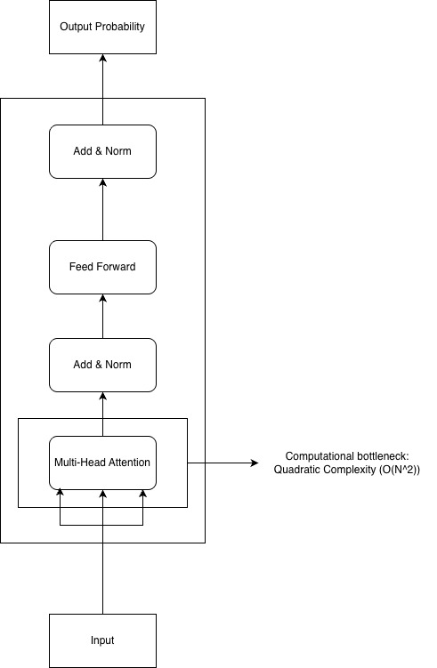
Figure 7.2.1 BERT Transformer Encoder Architecture View (Adapted from: Multi-lingual Intent Detection and Slot Filling in a Joint BERT-based Model )
The existing solution for public transport demand prediction applied BERT Transformer Encoder, (Jeong et al., 2024). In contrast to the full Transformer model used in translation task, only the Encoder structure optimized the understanding of historical time series data, without the Decoder. The core technique is the Multi-Head Attention mechanism within the Encoder. According to the Figure 7.2.1 Transformer Encoder Architecture View, this technique allows the model to process the entire sequence simultaneously. It calculate the correlations between each time step and all other time steps. For example, relating the passengers’ flow at 8:30 AM today to passengers’ flow at 8:30 AM last week. This capability helps the system to capture long-term dependencies that often get ignored by traditional RNNs.

7.3 The limitations of existing methods
Existing methods, excel in the performance of capturing long-term dependencies and offers high accuracy of demand prediction due to its Multi-Head Attention mechanism, it struggles in the critical limitation shown in Figure 7.2.1 BERT Transformer encoder architecture view. Although it contains with linear complexity such as Add & Norm layers and Feed Forward networks, its main Multi-Head Attention mechanism still requires to calculate pairwise relationships between all-time steps, leading to computational grow significantly with quadratic sequence length (O(N2)), making it inefficient in processing long-term historical data, indirectly cause the resource consumption. For instance, if the length of the historical input data doubles, it will quadruples the consumption of memory and computational resources.

7.4 Architecture view of proposed system
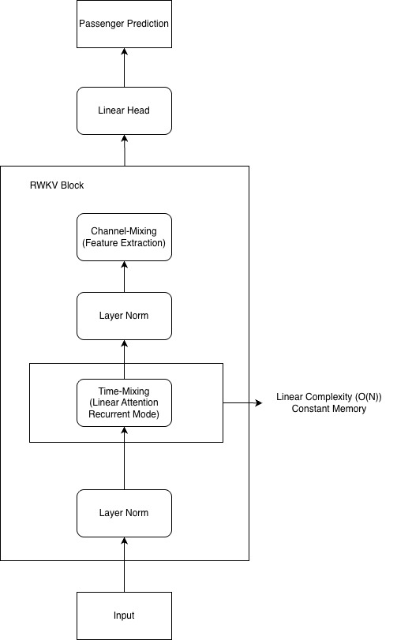
Figure 7.4.1 Architecture View of Proposed System
In contrast to Transformer-based Architecture, the proposed system architecture view illustrates that RWKV-based Architecture able to maintain high precision while low resource consumption. According to Figure 7.4.1 Architecture View of Proposed System, the core of the proposed system is Time-Mixing layer which include Linear Attention mechanism (O(N)) to capture long-term dependencies such as yearly passengers trends by performing linear interpolation between current and past information. Indirectly, this ensures that the memory remains constant during inference, regardless the input sequence length, also solve the issue of memory explosion of Transformer-based Architecture. The Channel-Mixing Layer is utilized to extracting non-linear features within each specific time step, which is similarly to the Feed Forward Networks of the Transformer-based Architecture, but it is optimized. This synergy of two layer allows the proposed system to process large-scale and long-sequence data with low resource consumption while maintain high prediction accuracy.

7.5 Logical view of proposed system
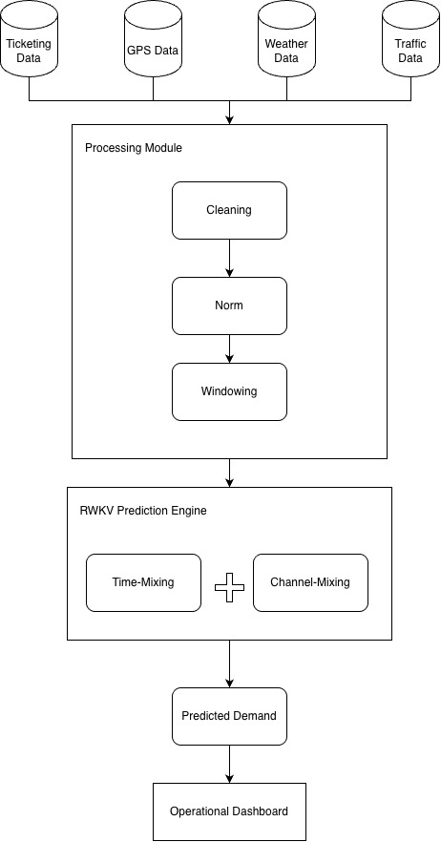
Figure 7.5.1 Logical View of Proposed System
As demonstrated in Figure 7.5.1 Logical View of Proposed System, the logical view of the proposed system defines a complete end-to-end data processing workflow, aim to transform raw urban traffic data into actionable operational insights. The process starts from the Data Acquisition stage, where historical passenger records are ingested from ticketing system, for example count the number of passengers paid ticket for bus, bus GPS logs that record the bus location, weather condition and traffic dynamics. Hereafter, these data undergo a strict Preprocessing stage, which include cleaning the abnormal and outliers, normalization and standardization, and generate sliding-window sequences suitable for prediction. These processed sequences then fed into RWKV Prediction Engine, where utilize Time-Mixing layer and Channel-Mixing layer to extract complex spatiotemporal patterns with linear computational efficiency (O(N)). Finally, the system outputs the predicted passengers demand for future time steps, then utilize it in operational dashboard to help bus operators make data-driven strategies regarding fleet scheduling and resource allocation.

8.0 Conclusion
This research has successfully examined demand prediction plays a critical role in public transport operations and identified that previous Deep Learning model such as BERT Transformer Encoder had significant limitations. It was found that while existing methods produce an accurate prediction, but due to its quadratic computational complexity (O(N2)) mechanism, it increases the resource wastage burden if need processing extensive historical. Consequently, this research proposed the application of RWKV-based architectures as a first-rate solution. By validating its performance to retain capture long-term dependencies through its Linear Attention mechanism (O(N)), the proposed system able to find the balance between high prediction accuracy and low resource consumption.
However, this research is subject to retain limitations. The current research focused primarily on historical passengers, GPS data, weather condition and traffic dynamic of specific routes. Consequently, the model’s generalization to different urban environment, different population patterns still needs to be fully verified. Besides, the current research model dependent on historical time-series sequences. Due to it no fully integrated complex external variable, such as sudden accidents, large-scale public events like concerts, which will affect the regularity of passengers flow, and affect the prediction accuracy indirectly. These limitations represent potential area for improvements in future systems.
(2314 words)

References
1. Almulhim, A. I., Sharifi, A., Aina, Y. A., Ahmad, S., Mora, L., Filho, W. L., & Abubakar, I. R. (2024). Charting sustainable urban development through a systematic review of SDG11 research. Nature Cities, 1(10), 677–685. https://doi.org/10.1038/s44284-024-00117-6
2. Castellucci, G., Bellomaria, V., Favalli, A., & Romagnoli, R. (2019). Multi-lingual intent detection and slot filling in a joint BERT-based model. arXiv. https://arxiv.org/abs/1907.02884
3. Fatorachian, H., & Kazemi, H. (2025). Sustainable optimization strategies for on-demand transportation systems: Enhancing efficiency and reducing energy use. Sustainable Environment, 11(1). https://doi.org/10.1080/27658511.2025.2464388
4. Jeong, S., Oh, C., & Jeong, J. (2024). BAT-Transformer: Prediction of Bus Arrival Time with Transformer Encoder for Smart Public Transportation System. Applied Sciences, 14(20), 9488. https://doi.org/10.3390/app14209488
5. Ku, C., Liu, C., & Wu, T. (2025). AI-Driven optimization for efficient public bus operations. Mathematics, 13(20), 3249. https://doi.org/10.3390/math13203249
6. Nayak, A. M., Ladha, A., & Chaubey, N. K. (2022). A Comprehensive Comparative Analysis of Passenger Demand Prediction for Improving the Urban Bus Transportation System (UBTS). International Journal of Engineering Trends and Technology, 70(9), 269–279. https://doi.org/10.14445/22315381/ijett-v70i9p227
7. Peng, B., Alcaide, E., Anthony, Q., Albalak, A., Arcadinho, S., Biderman, S., Cao, H., Cheng, X., Chung, M., Grella, M., Gv, K. K., He, X., Hou, H., Lin, J., Kazienko, P., Kocon, J., Kong, J., Koptyra, B., Lau, H., . . . Zhu, R. (2023). RWKV: Reinventing RNNs for the Transformer Era. arXiv (Cornell University). https://doi.org/10.48550/arxiv.2305.13048
8. Safiullin, R., & Arias, Z. P. (2024). Comprehensive Assessment of the Effectiveness of Passenger Transportation Processes using Intelligent Technologies. The Open Transportation Journal, 18(1). https://doi.org/10.2174/0126671212320514240611100437
9. Siswanto, J., Manongga, D., Sembiring, I., & Wijono, S. (2024). Deep learning based LSTM model for predicting the number of passengers for public transport bus operators. Jurnal Online Informatika, 9(1), 18–28. https://doi.org/10.15575/join.v9i1.1245

